Starting Jenkins

Open the command prompt. From the command prompt, browse to the directory where the jenkins.war file is present. Run the following command

D:\>Java –jar Jenkins.war

## Accessing Jenkins

Once Jenkins is up and running, one can access Jenkins from the link − **http://localhost:8080**

## Jenkins and Tomcat Setup

Copy the Jenkis.war file which was downloaded from the previous section and copy it to the webapps folder in the tomcat folder.

Now open the command prompt. From the command prompt, browse to the directory where the tomcat7 folder is location. Browse to the bin directory in this folder and run the start.bat file

E:\Apps\tomcat7\bin>startup.bat

‘Manage Plugins’ option.

In the ‘Filter’ tab type ‘Git plugin’

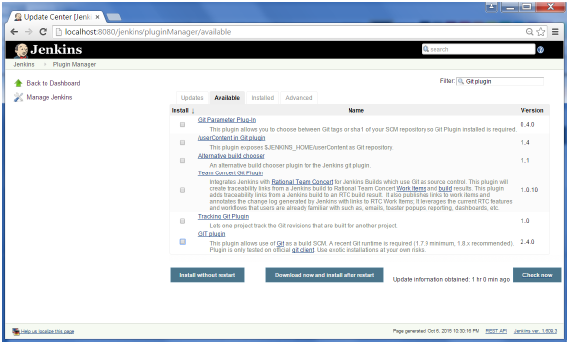

# Jenkins – Maven Setup